Investigation
In this section of the development process, I will be investigating the current system and what changes and additions I am required to make.
To do this, I will be conducting a study on the existing system provided by Cascades. Once I have completed a feasibility study, I will then study the present system in detail and bases on what I find I will then select the most appropriate type of investigation method for the current system. I aim for one of the methods of investigation to be to create a survey, in hope to gain some of this information as they are easy to create, time efficient and a large amount of people can answer the questions at the same time. I will also be conducting an interview with Mr Joot to collect information of the current system and how it could be improved to best suit the company. I will need to know:
- What data is needed, and how will it be collected and stored?
- What features are required in Average Joot’s new system?
- What are the major problems with the current system, and how am I going to rectify these?
I will also have to create an intuitive design for the new system; I will have to consider the following:
- What data is needed, and how will it be collected and stored?
- How will the information be displayed?
- What processes will the system run?
These aspects I aim to include in the design section of this project.
The system will be designed and created using VB.net which is provided by Microsoft. VB.net provides types of coding practices such as variables, modules, forms and 3D arrays. It is important that I ensure that I test the system to ensure it functions correctly and check for any errors/bugs so I can debug and ensure the system in functional and fit to be used by the Average Joot’s. This will be completed in the testing section where I will include my testing strategy and evidence of testing.

How I will Investigate

To conduct this investigation of the Current System for ‘Average Joot’s’, I will be making observations and analysing the current system left off, doing so well ensure that I gain awareness of any faults or flaws in the current system. To do so, I will be doing the following:

- Conducting a thorough, detailed interview with the Owner of the Gym, Mr Joot himself. This is one of the most important aspects of the investigation process as it will give me a strong insight into how the current system functions, and will also enable me to collect additional information about Average Joot’s itself. To prepare for this interview, I will be pre-planning some of the questions I plan to ask; via doing so I can get the correct and appropriate information to ensure that I am in a strong position for when I begin development of the prototype.

- Observing the system for myself, to see how the system itself functions and the issues with the system itself via using the system as If I was a receptionist, gym instructor and a customer to see how the system processes information. In doing so, I will have a feel for the system itself and be able to garner the concept of the prototype by observing its flaws and strongpoints, and acting upon these.

- Creating a Survey which staff members of the Gym can complete, which will consist of both tick boxes and areas for custom input. This enables me to both gain easy and consistent responses whilst getting more tailored results for questions in which answers differ depending on what the staff member’s role is.

- Getting into contact with the previous owner of the facility and maybe conducting a phone interview with him/her in hope to get information on the system which Mr Joot or his staff may have been unaware of. To do so I will be conducting research on the previous owner of the Facility (named “Cascades Leisure Centre”) in which the current system is still from and I will try to organise a meeting or conversation to discuss the system with him/her or if not, a previous staff member or associate.

Investigation

1) The Interview with Mr Joot:

In the first stage of the investigation process, I have arranged a formal interview with the owner of Average Joot’s Gym, Mr Joot. For this interview, I need to ensure that I am sufficiently prepared in terms of questions to ask and methods of getting a strong insight into both the ethos of the gym and how this information can be of use. In this interview there are various topics that I need to ensure I get sufficient information on to ensure this interview is a success:

- Firstly, I need to know what files the current system has, in terms of tables and software. This includes the file types, general file sizes and their general purposes.
- I also need to know the process of adding people and entities to the database; this includes adding new members and new staff members, as well as deleting members and staff members.
- Something else which I believe is important is to find out about how payments are held, including card information and payment types. As dependent on the wants and needs for the new system, it is important I find out what Mr Joot proposes in terms of payment options.
- I am also keen to know how, or even if the current system can track member’s progress; I believe that if this is not present, this is a needed addition which can benefit Average Joot’s hugely. Also, If there is an existing system; I’m curious to see its function so I know if refinement is required.
- I will also be asking Mr Joot about the company itself, their ambition and his role in the company. This will give me an insight into how Mr Joot can aid the development in terms of feedback, observations and financial backing.

On the next page, I have the plan for the questions I wish to ask Mr Joot.

Question Number | Question | Follow Up | Justification
1 | Can I get a Brief of you company, its purpose & its ethos? | What is your role in the company? | I am asking this in hope to garner a clearer understanding of the company and Mr Joot himself. Speaking to the owner himself will enable me to gain a stronger understanding of what he wants from the system and the person he is himself, in which I will progress with the interview accordingly.
2 | How is staff managed in this system? | Is proprietary software used or is it done within the system? | To understand how to approach staff management within the new system, it is important that I get Mr Joot to give me a clear and concise explanation to how the current system functions in terms of adding, storing, and managing staff members. From what I’ve heard, staff management is separated into two tables, one for instructors and the rest for other staff. I should try to address this rumour and find out if it is valid or just misconception.
3 | What current systems do you use? | Do the specifications enable the system to be used with fluidity? | It is important that I learn about the current systems Mr Joot uses. In doing so, I will be able to consolidate my options in terms of file storage and interface, to ensure it facilitates the specs given.  This is because I don’t want to develop a system which will be incompatible with Mr Joot’s systems in terms of specifications and of needs/requirements. Furthermore, Mr Joot may want compatibility to be considered with different operating system.  It is also important I consider how the specs limit the current system and how the new system may limit the current system. I also need to know how the current system performs in terms of fluidity and efficiency.
4 | In the current system, how are members added? | What changes would you like added for the process? If any… | Adding members is arguably one of the more important subjects of this interview, as it will be one of them more vital subjects of the current system. I need to garner an understanding of how the current system adds members as well as the effectiveness of this methodology.  This is so I know how to approach the current system. I also would like to hear suggestions from Mr Joot, In doing so, I will be able to hear about what he would personally like to have changed or added, and I will consider his input as he’s most likely used the system or his employees have and have given such feedback.
5 | How does the current system protect sensitive information such as bank details? | *Dependent on Response* | The subject of protecting sensitive data is most likely of high importance to Average Joot’s Gym, and understandably, as if negligence is shown during development, significant problems may arise putting the public, Average Joot’s Gym and our firm in danger. Therefore, It is important that a lot of consideration is made during the development of the new system in terms of personal detail storage and protection measures made. It is also important to find out how the current system stores sensitive information and ensure that Mr Joot is aware of any implications and risks, and provide confidence that these issues (if there are any) will be addressed.
6 | How are tables and file systems structured? | How are the files stored? | Finding out how tables and file systems are stored will be extremely beneficial to the development process of the new system. This is because I will be able to evaluate the structures in terms of advantages and disadvantages and either improve from current foundations or completely revamp the table structure.  I also would also like to find out how files are stored, in terms of formats and file directories. This is so I can know the limitations of the current system and consolidate any further action for the new system. I would also like to know about the file storage so I can compare to the specifications of the current storage options and progress from there.
7 | What is the purpose of the progress table? | How is the progress table used? | The progress table is also a very important part of the current system. An additional feature which is not utilised correctly in the current system according to a title update changelog from Naguarsoft’s V2.01.30 (the current latest update released late 2013) which suggests “The limits of progress are reached, and any further additions will be problematic to the function of the system. Therefore, the progress table has and will remain the same in terms of features; excluding bug fixes.  Since there has been no updates to the progress table of the current system. I’m curious to know about the function and how the table is problematic towards the function of the entire system. To find out, I need to ask Mr Joot what the purpose is of this table as well as how it is used. So I can see where Naguarsoft has gone wrong, and ensure I do not repeat mistakes.
8 | Would you like to have a progress table in the new system? | What differences would you prefer? | Despite my knowledge of the gym, I am unsure if there even is a necessity of the progress table. Mr Joot may have separate tracking software or another solution. So it is important that I clarify the need so I don’t implement unnecessary features.  If Mr Joot wants a progress table, I would like to know all the details what are required and how he would intend it to function. Therefore, I will be able to know how I should create the progress table to ensure it meets Mr Joot’s needs and requirements. I especially need to be wary about my approach to the creation of the progress table, as I do not want it to interfere the function of other tables.
9 | What Features would you like implemented into the new system? | Any notably important features? | Asking Mr Joot on what he wants as improvements will be extremely beneficial to the creation of the current system. I will be able to gain a strong indication on the kind of system he is looking for in a brief, as well as enable me to gain an understanding of Mr Joot’s expectations. Furthermore, I will have to ensure that I will

It is important to know questions may slightly change based on context and the situation. So these question plans will act as a guideline.

The Interview

Time: 13:00
Location: Office-For-Hire, Gillingham, Kent

Interviewer: Manjoot Narwal
Interviewee: Mr Joot

Manjoot: Good Morning Mr Joot, It’s a pleasure to have you in my company. Today I will be conducting an Interview with you in regards to your current database solution for your company Average Joot’s Gym, is that correct?

Mr Joot: Yes, yes that is!

Manjoot: Excellent! I just want to know a few things about your current solution in terms of how it functions, what it does and what it looks like- and from there I can garner an idea of the needs and requirements for the newer solution. This information is crucial to ensure I tailor the new system to your current setup and I know what changes and additions are required. So what I’m going to do in today’s meeting is just ask you some questions, with the inclusion of follow ups; and from there I will take some notes. I will also be logging and recording this Interview for referential purposes, in which all your rights are reserved for this period. Sounds good?

Mr Joot: Yes, that is perfect!

Manjoot: Okay, firstly I would like to get to know your gym a bit better. So could you please give a brief on your business, its ethos and what your role is to the company?

Mr Joot: Why Certainly! My name is James Joot, and I’ve always had an interest in sports and fitness. Ever since I was the age of 5, I have had a strong passion for the sport of Boxing. My father would always show me the latest matches on television, and from the age of 9 I joined an amateur boxing club; in which I participated there until the age of 18, in which I went to university and pursued a career in finance. However, after completing my economics degree and working in Investment Banking for 15 years; I saw an opportunity in a dying gym based in Gravesend, Kent. Which was formerly known as Cascades, I assume you are aware. I had always had a passion for sport and fitness, and I was feeling unfulfilled in my current job, in which time was a virtue. So then I made the investment of taking over Cascades 6 months ago, and I have rebranded it as “Average Joot’s Gym”.

In terms of the company, in short: I am the owner. So this would consist of me fulfilling all the roles you’d tend to expect an owner to fulfill. This includes management of staff, management of finance and management of the establishment.

Manjoot: You mentioned that you manage staff, do you do this by a proprietary software or does the current system feature this ability?

Mr Joot: Staff management is done via the current system. However, the current system is relatively basic in terms of functionality in this aspect. We can only store personal information and salary bands, and admittedly there’s no indexing or encryption which means there is a possible security risk. This is especially worrisome when you realise that the personal data of our staff is at jeopardy, and unsettles the receptionists who handle the data. Also, the system itself is a tad… old. Therefore, performing system backups take around 3 hours, also navigating through the UI is very slow with constant lag; despite our computer systems being relatively new and powerful.

Manjoot: Oh okay, what current computer systems do you use now? I mean in terms of specifications and infrastructure?

Mr Joot: Currently, have about 10 active computer systems in the gym (excluding systems used for fitness). 2 mid-range personal computers (Core i5 and 4GB Ram, both with PCIE network cards from Intel and connected to the server), located at the reception. 3 Located in the Admin Office (Core i7, 8gb RAM and connected to the sever, as well as each system having 1TB of local storage per user). 3 Trainers are also allocated surface pro computers (The 2015 Models) which they used to manually track field and swimming races, as well as log damages made to equipment by members. We do not use the integrated features in the current system for this because the current system is less responsive and isn’t the most touchscreen friendly when required. We have one mid-range system which handles CCTV (i5 and 12gb RAM with 10tb Local Storage) and finally my system in my office which has an i7, 16gb RAM and a Generic Nvidia GPU.

Manjoot: Okay. What is the process of adding new members to the gym?

Mr Joot: Well, the process itself is relatively simple. So, a new member will either send an email enquiry from our website, phone the reception or pop into the gym to start. We will ask them details, get identification and ask them which package they want. Then we input the data into a basic validation form provided in the current system. Like a basic window with each text box for input, not really any validation so receptionists will make typos and we’ve had problems with contact due to little mistakes due to the lack of validation. The window will have two buttons on the bottom right of the screen. One saying “SUBMIT” and one saying “BACK TO HOME”. Inputs include… Name, Surname, Age, Home Address, Membership Type, Payment Method, Expiry date and then the correct information if relevant. The interface isn’t very tidy and looks outdated, with inconsistent spacing of text boxes and no formats for the text boxes, so in short: anything could be inputted into the text boxes.

*A Mockup of what the interface may look like, based on information provided by Mr Joot.
BACK TO HOME
SUBMIT DATA
First Name:
Surname:
Date of Birth:
Home Address:
Membership Type:
Payment Method:
Card Details:
Member Expiry Date:
Manjoot: Oh right. For a new system, what changes would you like made to the method of adding new members?

Mr Joot: Well first are foremost; a more cleaner and professional interface to adding members would be preferred. As this will make using the software much easier and more efficient. This can be by a change in layout or aesthetics. Another improvement would be the addition of validation; as its absence has always been a surprise to me. I also wish there was more options to add for payments, such as cash or direct debit; as well as the ability to give more in depth options for user addition; such as genders, medical information, full home addresses.

Manjoot: …you talk about payment methods. How are payment methods held and is there any degree of security when they are added?

Mr Joot: Unfortunately, there is no security except the antivirus! Also, payment methods are held in the record corresponding to the member who owns the payment method within the Members Table.

Manjoot: But what about data protection within the system? Is there no security such as passwords, encryption to sensitive data or even indexing within the current system?

Mr Joot: There is an administration password to access the software itself, and that is all of the security; which is worrisome due to the potential risk of hacking, as well as the server running on network attached storage and being protected by only another password and an antivirus.
Manjoot: Well that’s a point which, in my honest opinion definitely needs to be addressed and I will be taking security into consideration in the creation of the new system. In terms of files and tables; what is the structure like in this aspect? In which how are the files stored on server and how do the tables relate in the structure?
Mr Joot: In terms of tables, there are about 4 of them. We have a members table, program table, progress table and staff table. The members table consists of member details (including a primary key, name, surname, DOB etc.), the program table has fitness programs conducted by various trainers which integrate with calendars on Microsoft outlook to show my trainer’s availabilities throughout the day. The staff table contains details for all the staff members including trainers, security and cleaners. However, I feel this restricts capabilities with trainers as the use of the data is limited. Also, the progress table is a table which tracks user progress, having the unique identifier for the corresponding member and their progress on particular weight lifts, track times etc.
The NAS server has 10tb of storage space, and is used to store both the database itself as well as weekly backups.
The file system for the NAS consists of the parent folder “SERVER-MAIN”, followed by the tables in spreadsheets, access files for relationships etc. and another parent folder “SERVER-BACKUPS” which has a separate backup file of the data for each week, which is updated daily during the corresponding week. The “SERVER-MAIN” consumes around 6mb of storage at the moment and each backup containing similar. The backup folder consumes around 200mb of the storage.

*What the file structure of the HDD may consist of based on Mr Joot’s Input.

Manjoot: Oh okay, excellent. I heard you talk about a progress table. What is the intended purpose of this table and how is it currently used?
Mr Joot: The software does not give the strongest indication of its intended purpose. However, we were able to work out it is used to track the progress of users. However, the solution itself isn’t the most adaptable, as it has pre-set headings such as “powerlift weight” which we do not require and we are not given the option of removal. This is a massive inconvenience in many circumstances when querying the data and consumes storage space in the process.
The member will enter his ID into a machine, he/she will do the corresponding workout and the results will be logged onto their id, and if they attain higher within a week their score will be updated. We log their weekly attainment in workouts and enable members to access this information online. There are flaws with this, as data from the machines do not always transfer correctly to the database due to the frequency of data updates made on the main database, which is every 30 seconds and cannot be changed or disabled. Also, only a small set of machines work on this as there’s no option to add more workout machines.
Manjoot: Would you like to have such a solution in the new system? If so what differences would you prefer?
Mr Joot: Definitely for custom activites to be on the progress table, as well as better integration with Excel so transferring data from other devices is easier.
Manjoot: Okay, one final question. What are the most important features you want to see implemented into the new system?
Mr Joot: Definitely a cleaner, simple and more aesthetically pleasing interface. Also, something I forgot to mention; one of my receptionists is colourblind and cannot see the colour red; so I’d like the interface to be colour-blind friendly as well. Also, I’d like better integration with default database software such as Microsoft excel and notepad. However, the most important feature for me is definitely a better way to track progress for customers, as well as be able to have a new and refined booking system. For you, I have left a copy of the software with last week’s backup, and I give you permission to use the software and observe the data; I have also removed payment details for privacy reasons. However, the database should still be fully functional. Please use this for referential purposes and for research.
Manjoot: Thank you, also this concludes our interview. Thank you for your time!

2) Current System Observation:

In the second stage of the investigation, I will be investigating the current system via observation. This observation will be made possible by a USB containing the latest build of the program, provided by Mr Joot. In Doing So I will be able to garner a strong indication of what the current system looks like, it’s benefits hands on and its drawbacks and from there; I can make decisions on what additions need to be included into the new system.
The computer system I will be using to test the current to test the current build is my personal computer. This system has an overclocked Core i5 and a GTX 970 graphics card, which should be adequate enough to run the current build. The current system was last modified in February 2015, based upon the properties when right clicking on the executable.
Upon opening the file, I was prompted to a “Run as Administrator” popup, in which I clicked yes. From then, I was prompted to a “Login” page. In which I used the pre-set login “admin” and “fitsoft123” provided by Mr Joot.
Login

FitSoft
Database Software
Password:
Username:
Upon Entering the database, I was prompted to a main dashboard, which consisted of solely buttons and break lines going horizontal; with a purpose of distinguishing subsets of commands. The design was very simplistic with linear colour schemes and basic shapes/fonts for buttons.

Help
FitSoft Database Software
Logout
Make Booking
View Programmes
Edit Programmes
Edit/Remove Programmes
Backup Data
Settings
Analysis
Search Trainers
Remove Trainers
View All Trainers
Add New Trainer
Add New Member
View All Members
Remove Member
Search Members

Welcome – Administrator

Below: I am going to show various mockups of the interface based on my usage, this will include

First Name:
Surname:
Date of Birth:
Home Address:
Membership Type:
Payment Method:
Card Details:
Member Expiry Date:
BACK TO HOME
SUBMIT DATA

This window represents the “Add New Member” form. This form consists of the same simplistic themes as the Main Switchboard, with a blue background, white labels used to label text boxes and black bordered text boxes. There are two buttons “Back to Home” and “Submit Data” which function as they should be. Furthermore, there is no option for me to close the application; which means that to exit the application. I must click “back to home” and then “Logout” on the top right of the main switchboard. I’d imagine this to be a massive inconvenience for most, as well as being significantly unproductive as to navigate between different forms will be more time consuming and multitasking will be more difficult, if not impossible. To address this: Naguarsoft should’ve implemented a close option for each window, as well as keep the main switchboard open at all times; so users can refer to another table for referential purposes. This is an eye opener and something I’d wish to get context on when I go on to interview Simon or Babatunde Naguar.
The next form I will be viewing and using is the “View all Members” Form, this is a form which shows all the current members within a table, which you can drag down and view.

VIEW ALL MEMBERS

Input:
//
John Smith- 18M ID: 123
Harry Parker- 24M ID: 654
Alex Watling- 22F ID: 585
Jake Clarke- 34M ID: 094
Tommy Lee- 41M ID: 249
Harriot Wright- 28F ID: 377
John Smith- 18M(2) ID: 886
Dorothy Wilkins- 52F ID: 401

Search by First Name
Search by Surname
Search by ID

Search

Back to Home
Clear Text Fields

This window maintains the entire program’s styling theme of blue and grey, with the simplistic button layout and generic windows form features. On the top of the form, there is the text “View all Members” to give users the indication that the current form’s purpose is to view all members of the gym. There is a flaw within this function as the scroll bar is located inbetween the name and the ID. The initial order of the displayed data is based upon when the data was imported, however, a search option is available which can search by name, surname or ID but only one of these 3 parameters. There is also a “Clear Text Fields”, which clears the table and clears the data entry input.
The “Search” button then searches by the refinement and works as intended. The “Back to Home” button also works as intended, closes the form and opens the main menu.

From there, the remainder of the forms maintain this type of layout and colour scheme, something I must accredit Naguarsoft for.

DELETE MEMBERS

Back to Home
John Smith- 18M ID: 123
Harry Parker- 24M ID: 654
Alex Watling- 22F ID: 585
Jake Clarke- 34M ID: 094
Tommy Lee- 41M ID: 249
Harriot Wright- 28F ID: 377
John Smith- 18M(2) ID: 886
Dorothy Wilkins- 52F ID: 401

Delete

In the “Delete Member” form, there is a table which resembles the table from the “Add Member” section, from here, you can select a name and delete the selected member by pressing the delete button. Personally, I think this form lacks the efficiency expected from a form purposed to delete a member. However, like the “View All Members” form, there are inconsistencies, for example: The lack of order in the names is once again present, and names are placed in the list in a random order. This wouldn’t be problematic if the list itself wasn’t large, however: due to it being of a large size, finding the right member in a feasible time can be difficult to impossible.

In terms of analysis or processing, this function is very basic and only shows analysis for members and programs.

Back to Home
ANALYSIS

Most Popular Member: 377
Most Popular Program: 12

The analysis shown includes the “Most Popular Member”, as well as the “Most Popular Program”. These both then show the corresponding ID, for the most popular member as well as the most popular program. Only showing the ID can prove counterproductive as to identify the member, the user would have to go back to home and then view all members and go through the unordered list to find the member ID 377. This process would also apply to the most popular program, although not being as inconvenient due to the lower amount of programs present in proportion to members.
The forms representing the other tables have a generally similar style as well as layout and perform the same functions. An example is presented below for view all trainers.

VIEW ALL TRAINERS
Harrison Watling- 18M ID: 12
Denise Gibbs- 48F ID: 6
Joe Bloggs- 28M ID: 5
Thomas Simmonds- 34M ID: 9
Harrogate Smith- 41M ID: 4
Joseph Adenuga- 25M ID: 7
Jason Vasquez- 19M ID: 8
Ellie Smith- 22F ID: 15

Back to Home
Clear Text Fields
Search
//
Input:
Search by First Name
Search by Surname
Search by ID

As you can see, the layout is extremely similar to the “view all members” form, in fact is exactly the same as the “view all members”. This is something which makes sense, as consistency is important for a good user interface. This is a habit I wish to maintain when developing the new system for average joot’s gym.

3) User Survey
The third investigation method for this project will consist of me making a Survey which staff members of the Gym can complete, which will consist of both tick boxes and areas for custom input. This enables me to both gain easy and consistent responses whilst getting more tailored results for questions in which answers differ depending on what the staff member’s role is.
I will be using google forms for the user surveys, due to both the convenience and accessibility of google forms. This being because google forms is accessible on mobile as well as PC, which makes completing the survey easier and more convenient for staff members. I had 4 users complete the survey, two receptionists as well as two trainers. The surveys will be completed anonymously, this being for privacy purposes.

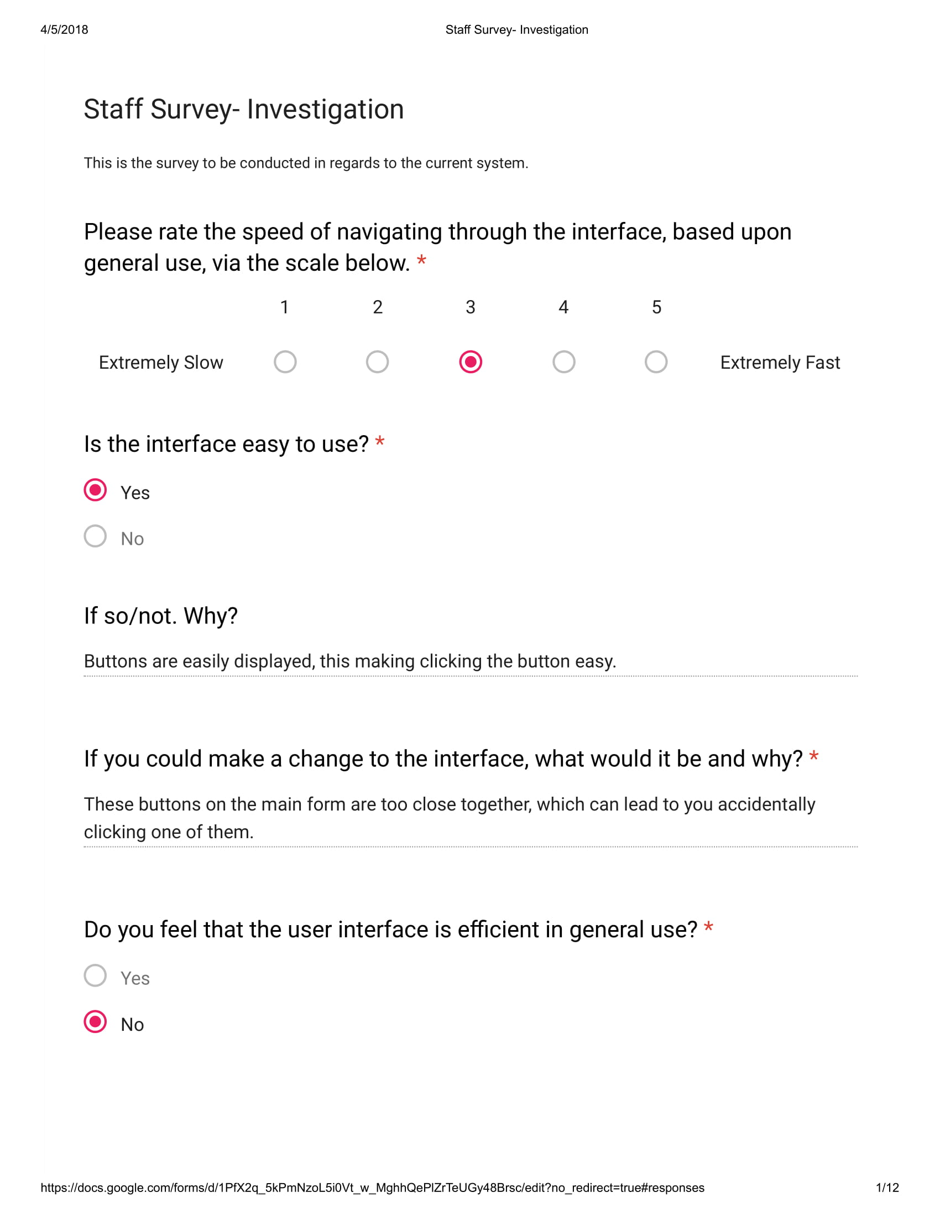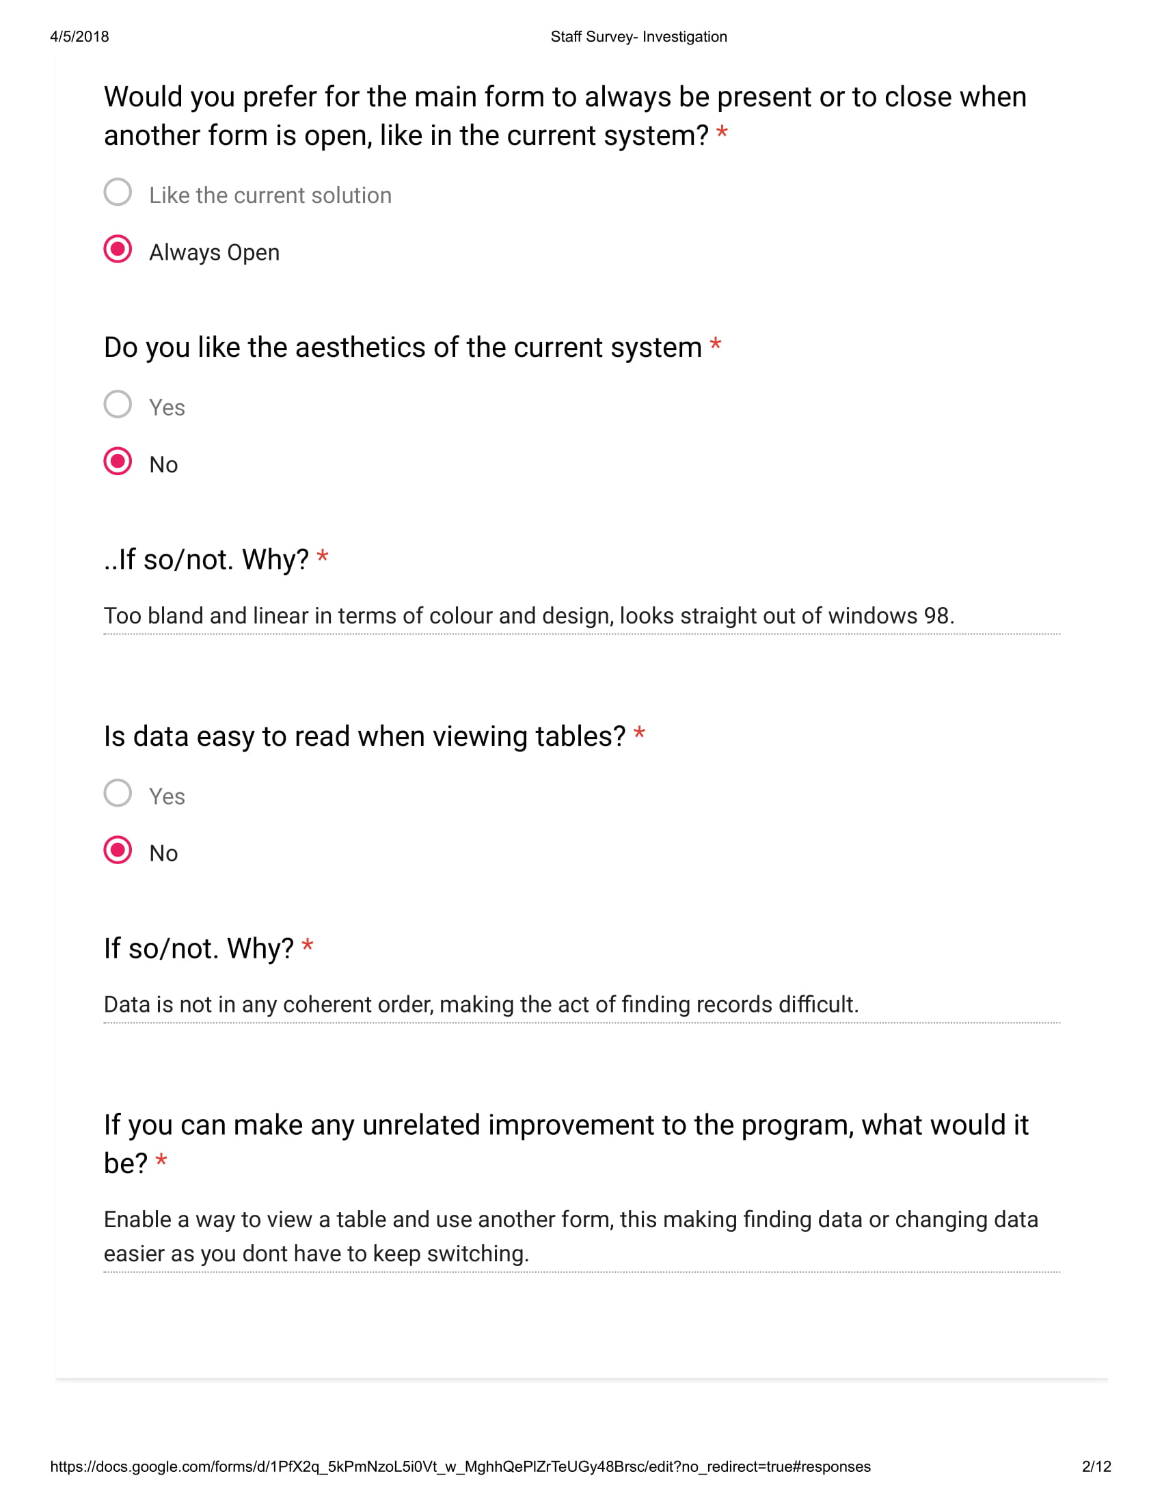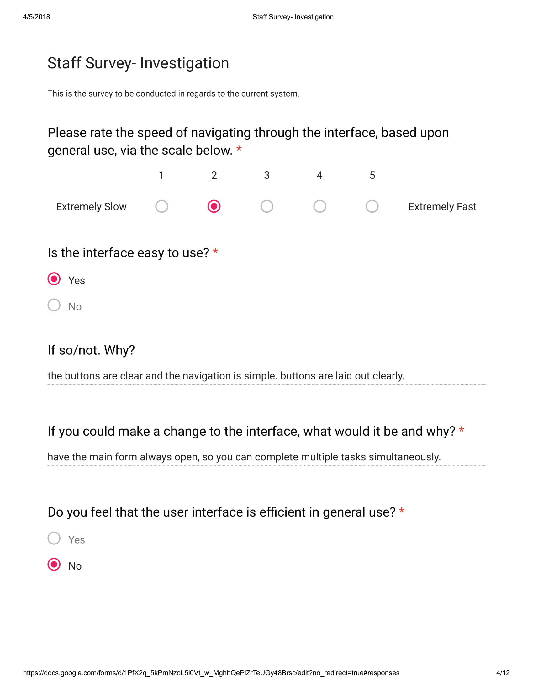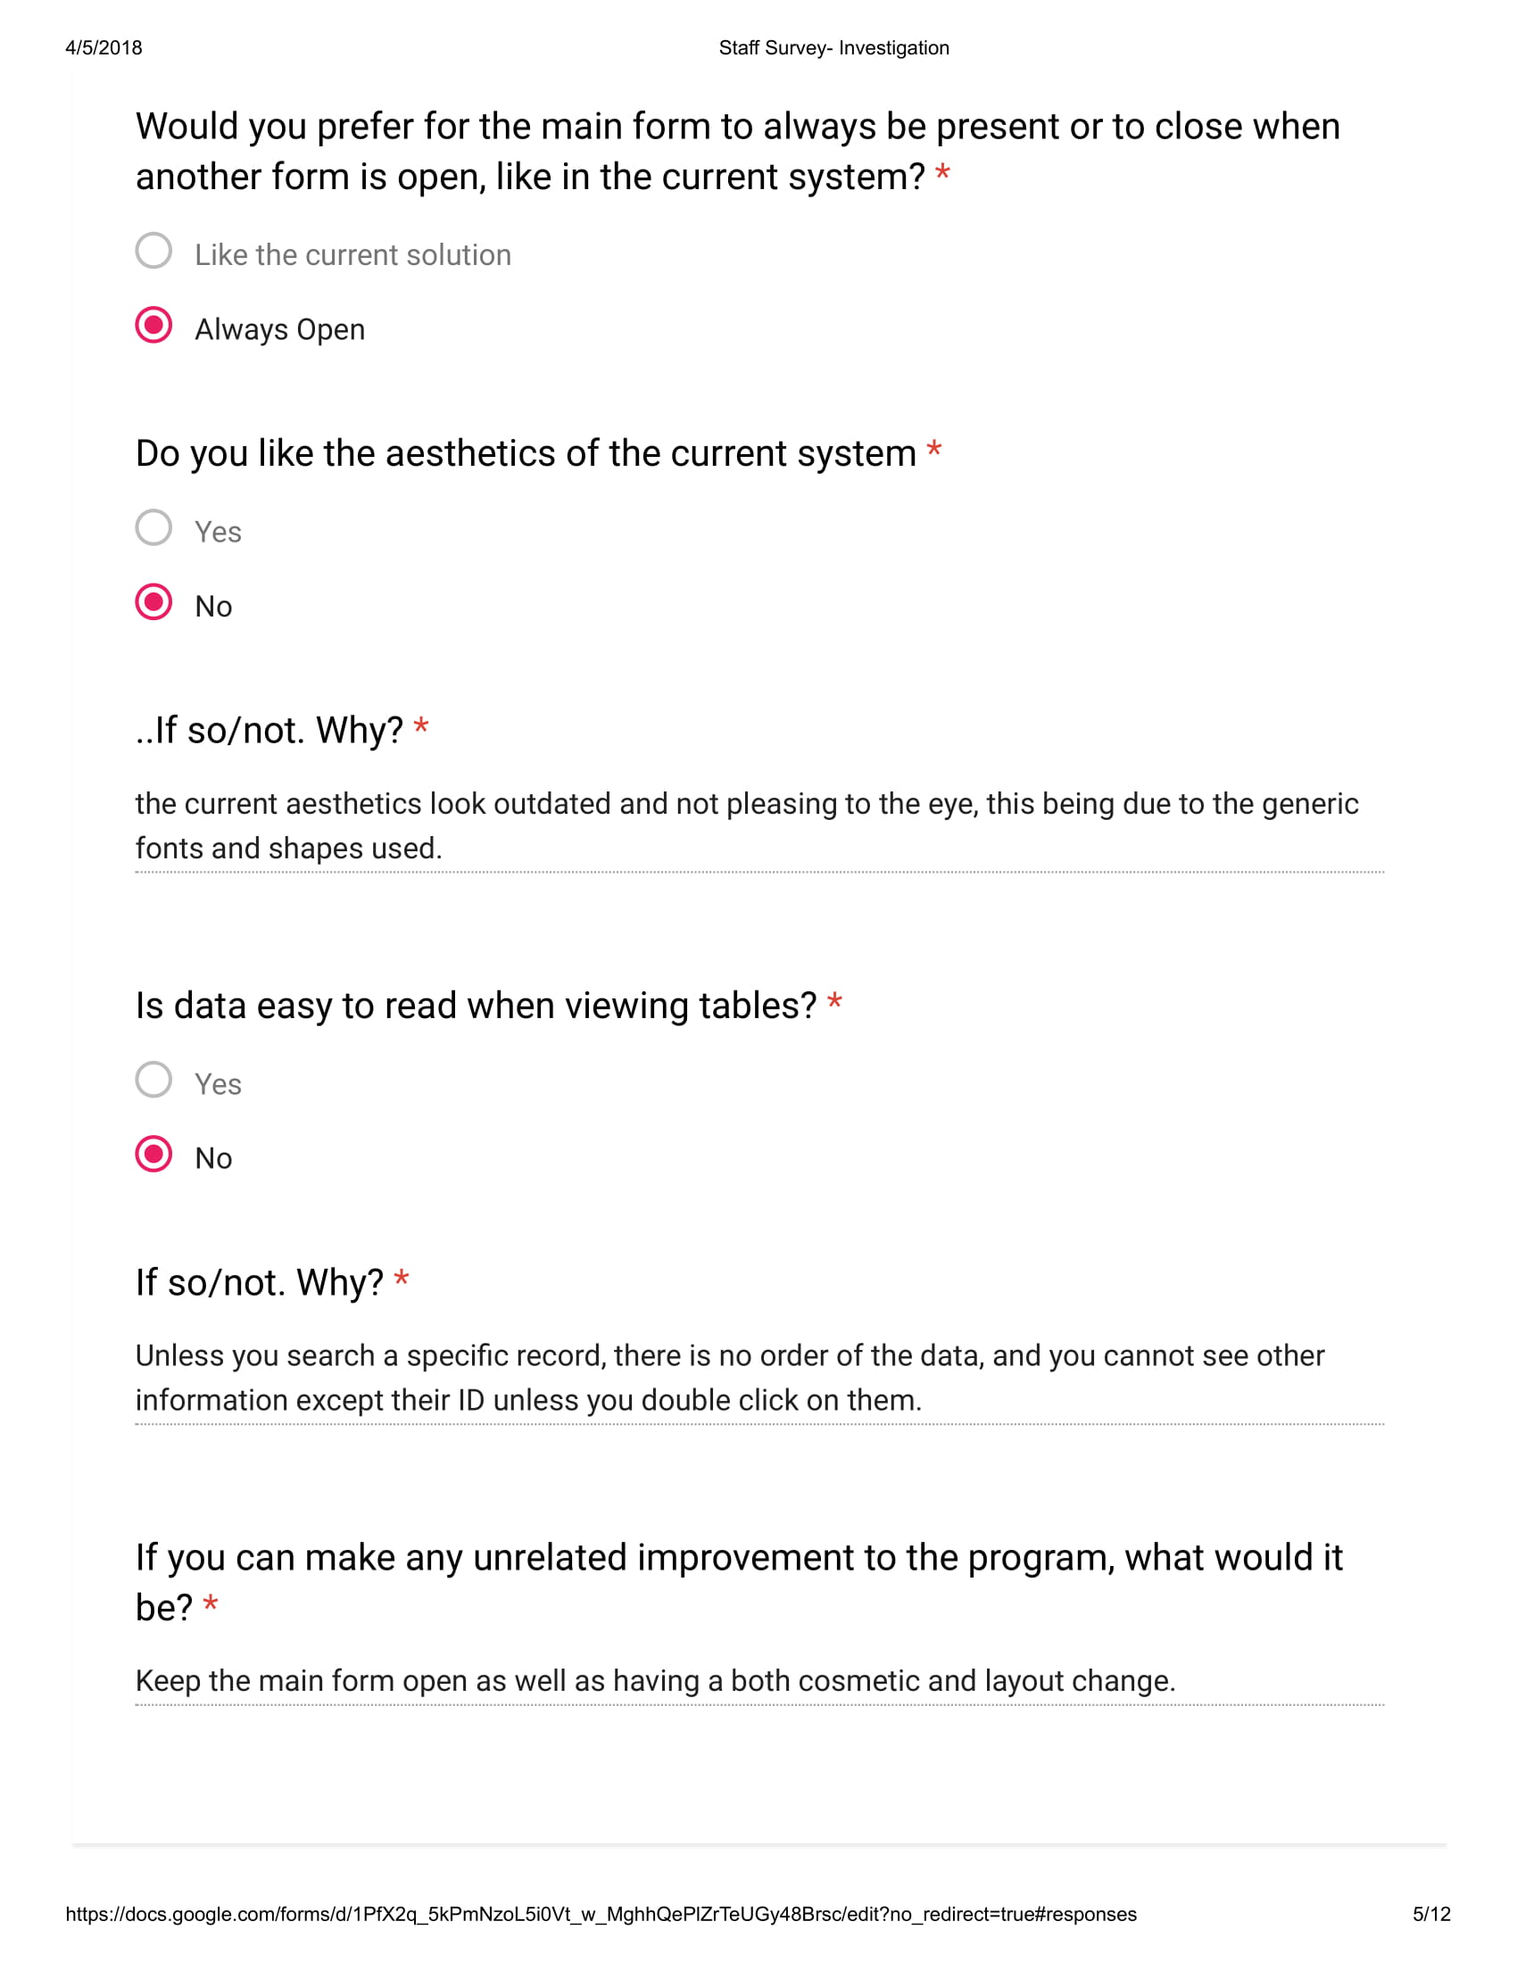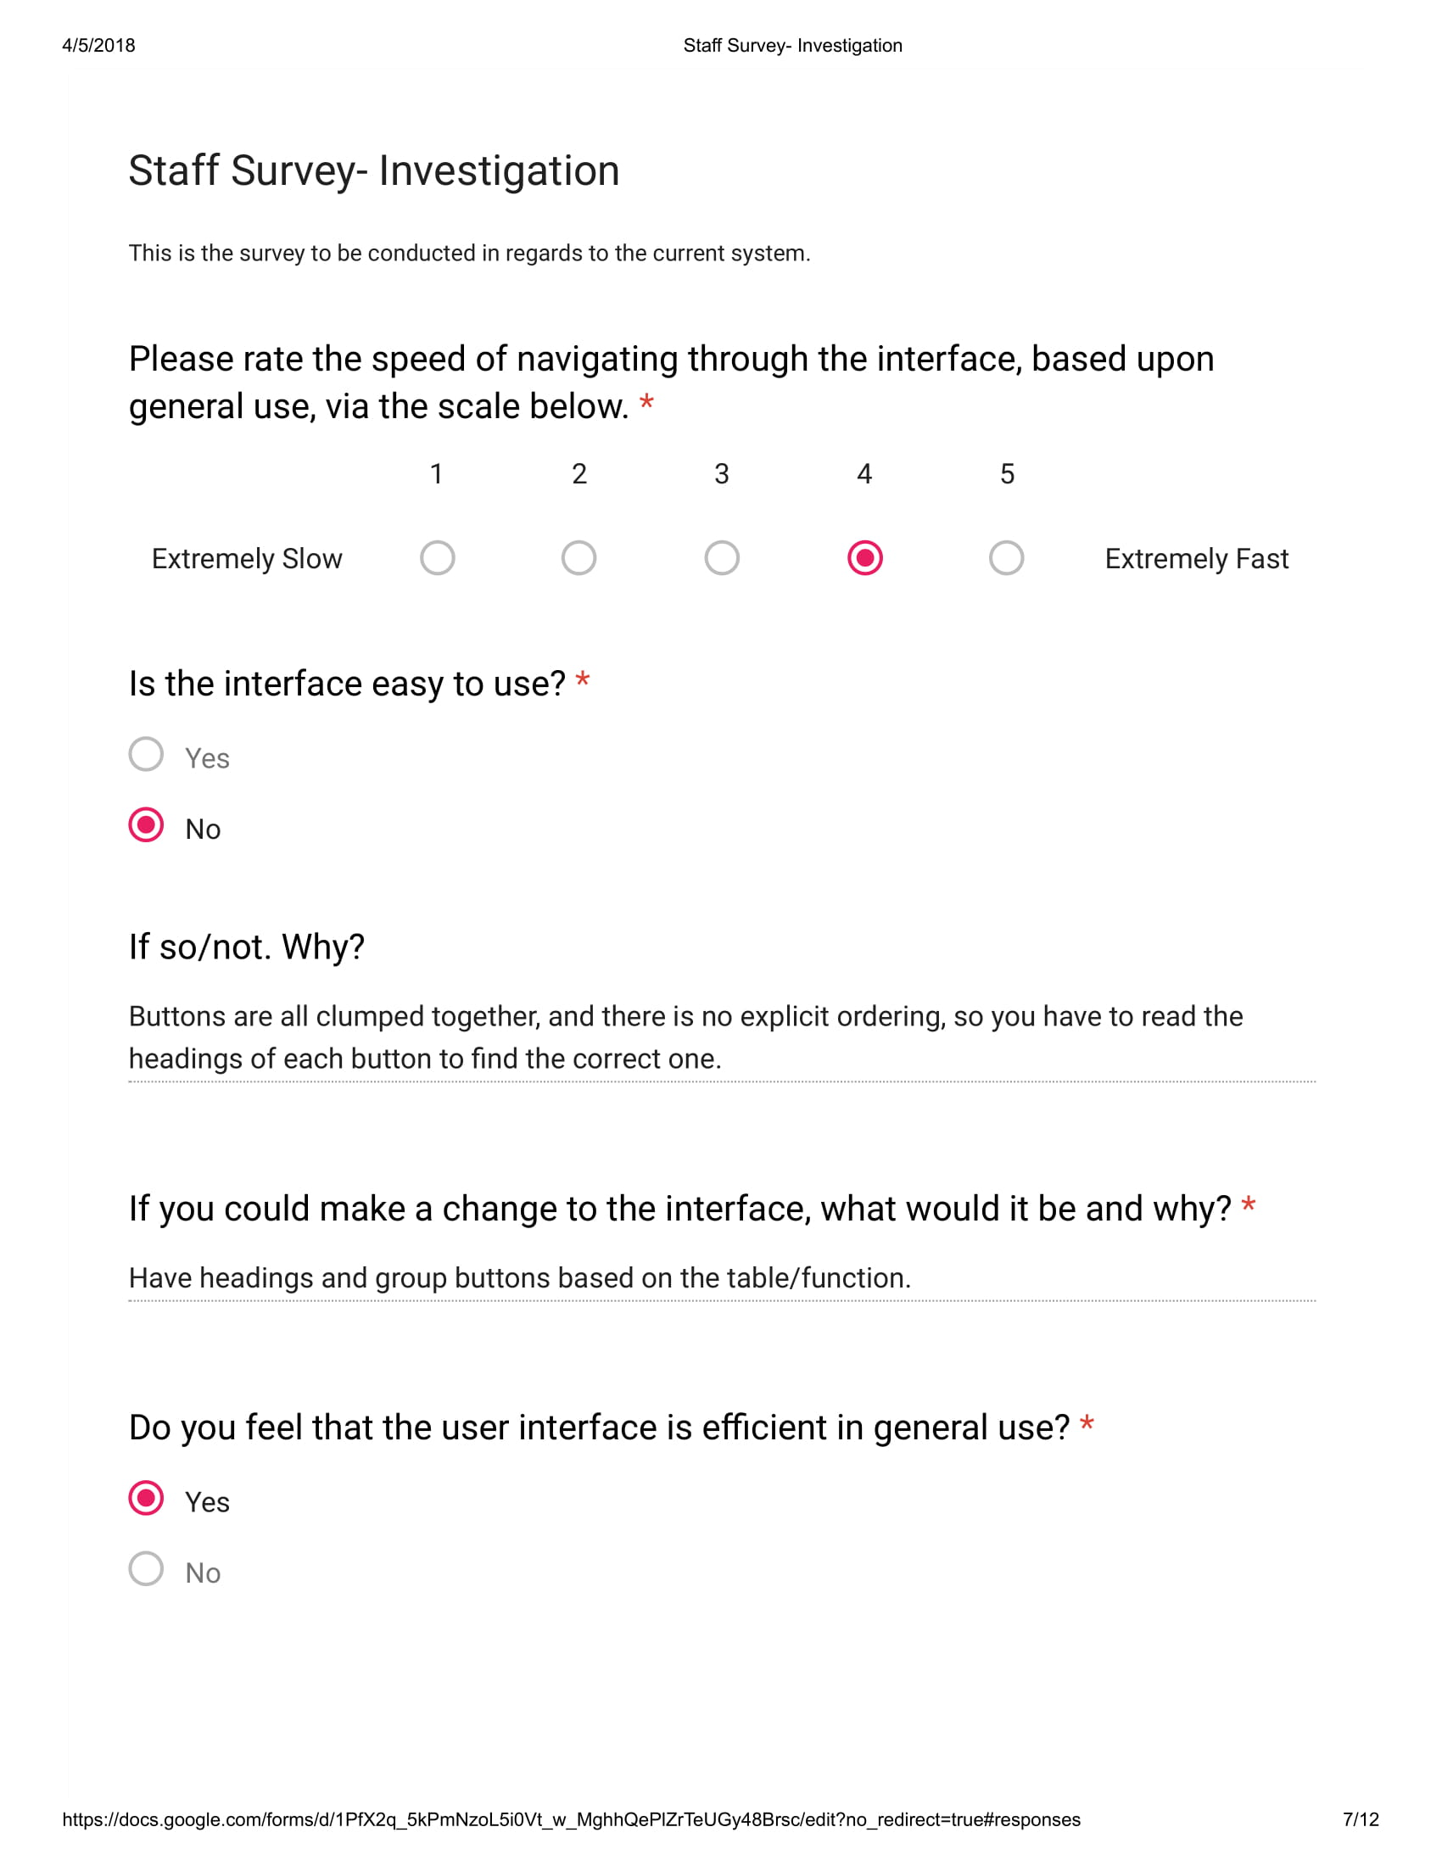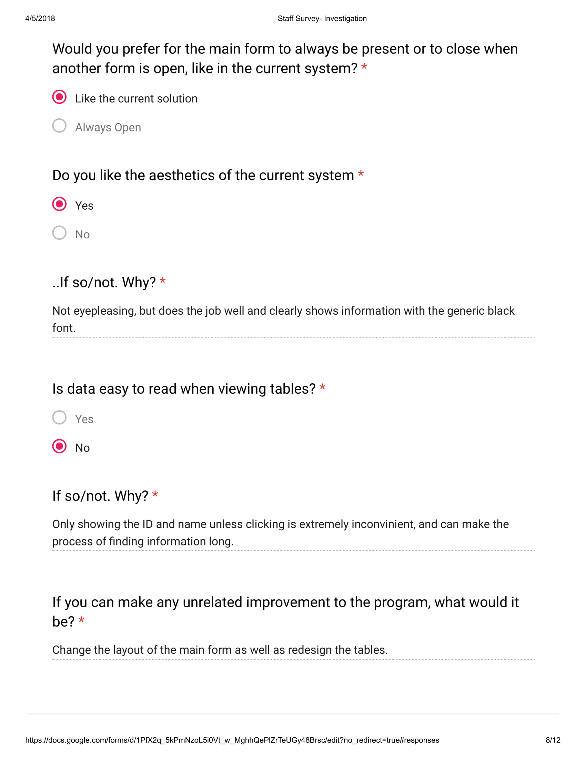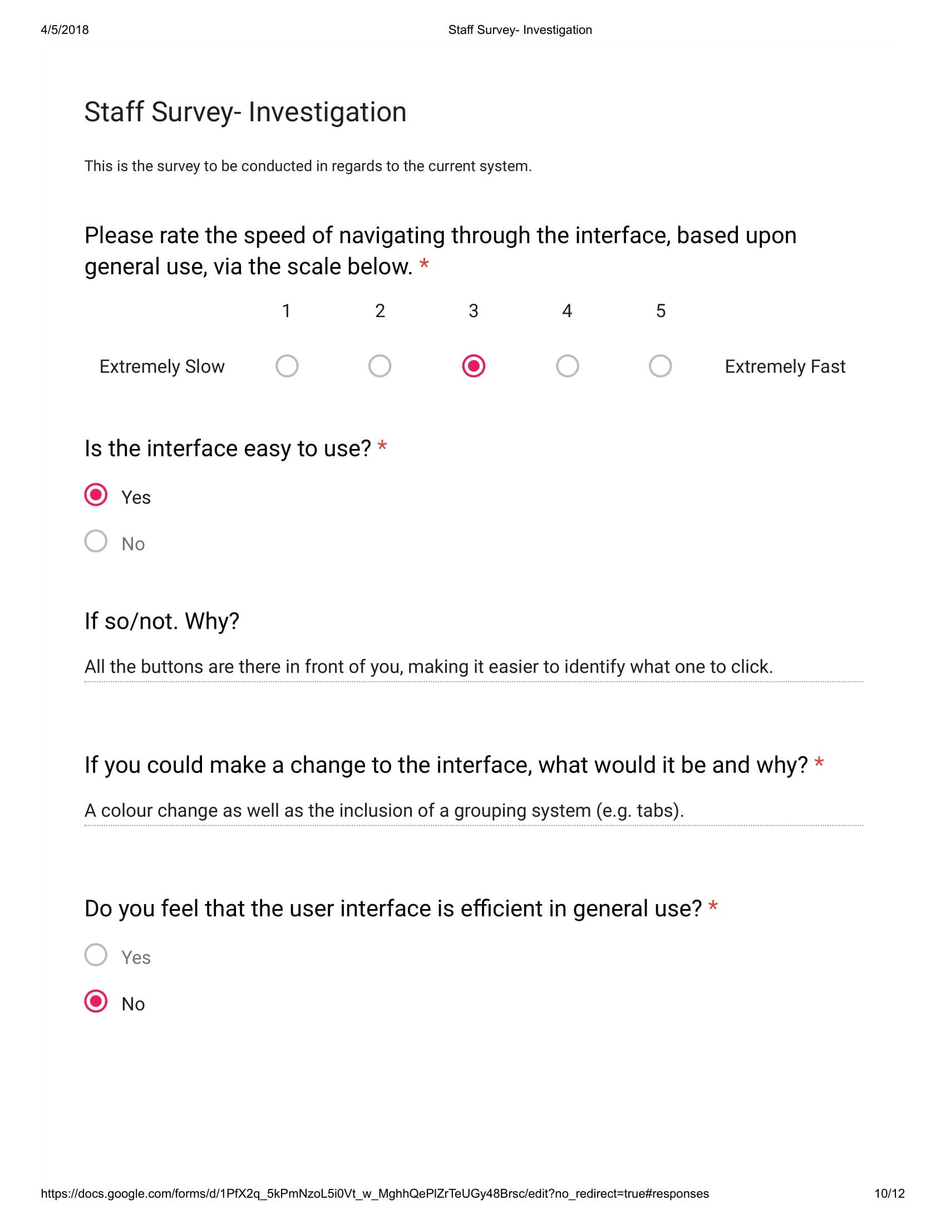

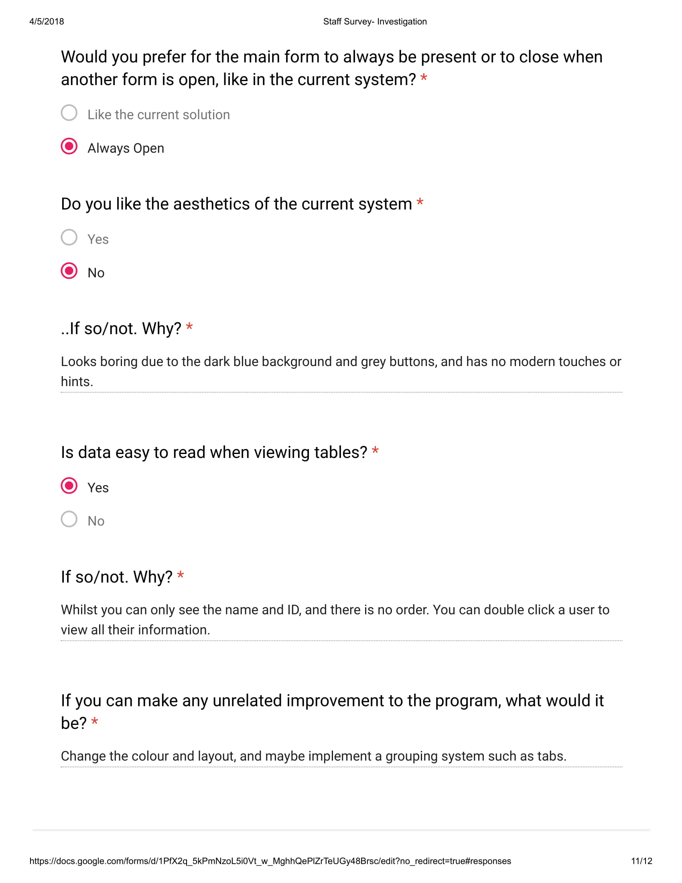
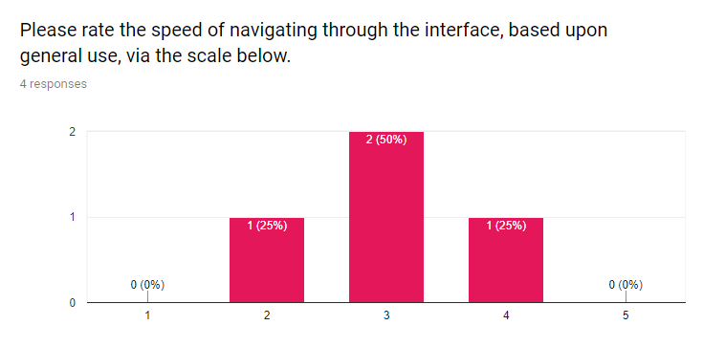
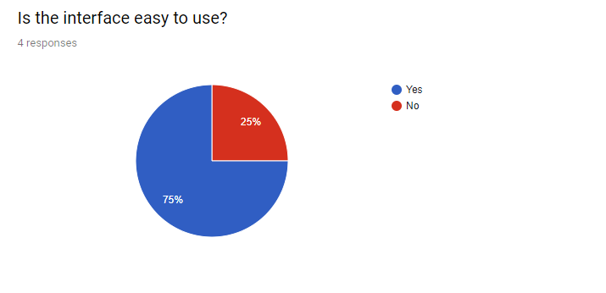

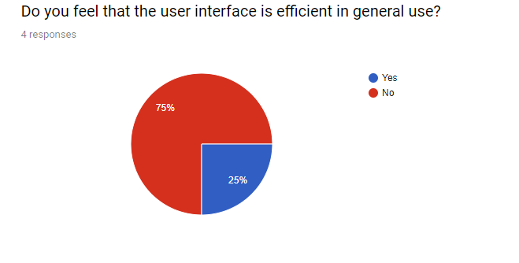
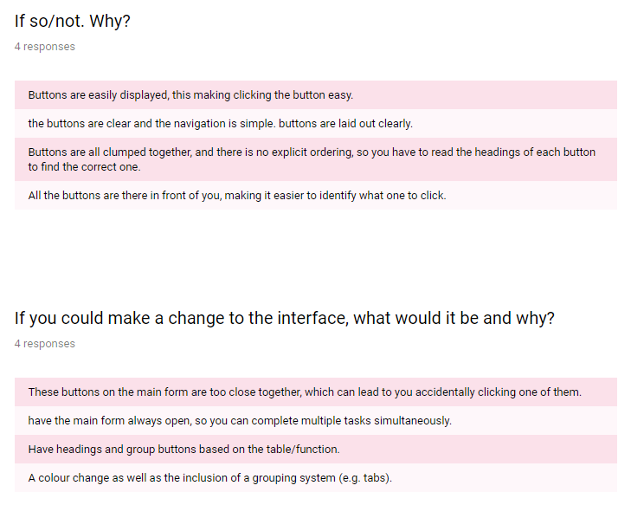

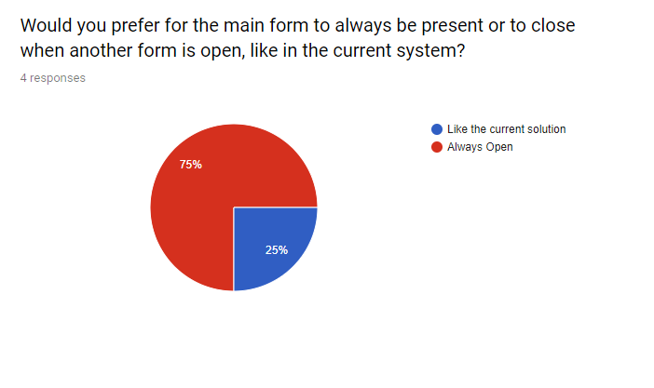

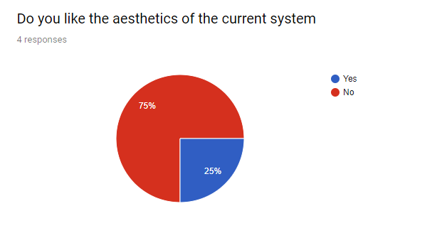

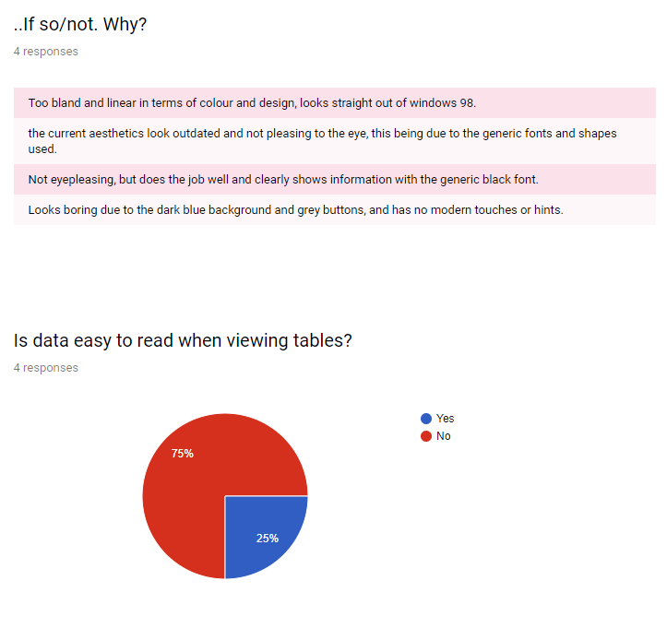

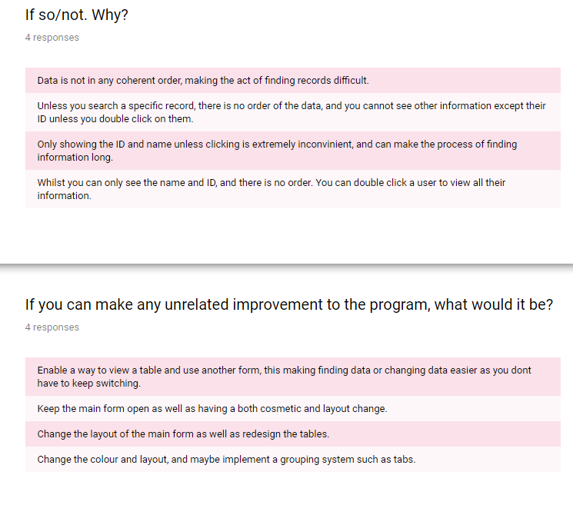

Conclusion based on feedback
Overall, based on the feedback provided by the 4 users I have concluded:
- The current system is adequate in terms of speed of navigation, however: can be better. This being due to the fact none of the users rated the speed a level 5.
- 3 out of 4 of the users said that the interface was easy to use.
- This being due to the size of the buttons as well as their clarity in terms of labelling. However, one response suggested that headings would be useful to distinguish the category of the button.
- In terms of suggestions for a new interface, a notable suggestion was both the grouping of buttons/functions via a mechanism such as tabs, as well as having an more open interface for the buttons.
- 3 out of 4 users said that the current interface was efficient, therefore: the current system has a level of efficiency which is beneficial for users. This may be most likely the simplicity of the interface stated in the feedback.
- 3 out of 4 users would prefer for the main form to be always open, as opposed to the current system in which only the current form is open. Therefore, in the new system I may keep it open.
- 3 out of 4 users do not like the aesthetics of the current systems. Many stating that the current system is “too bland” and “outdated”, one in fact referencing windows 98 and another stating its lack of modern touches. Therefore, in the new system: I must pay particular attention in making the system look modern.
- 3 out of 4 users said that viewing data from the table was not easy, this being due to the lack of information presented within an initial record as well as the strange order, therefore, this must be addressed in the new system.
- In terms of unrelated improvements to the current system: there were suggestions of adding a tab system as well as a layout redesign of both the forms and tables.
This process has enabled me to gain a strong indication of the type of project as well as the expectations. From there, this builds the foundation for me to begin my design process. This system will be developed to facilitate the users needs and requirements, and to combat the flaws within the current system.

4) Communicating with Previous Owner
In this section of the investigation, I will be attempting to get in contact with the former owner of the gym premises and former owner of “Cascades Leisure Centre”. I will first be conducting basic research on the owner as well as trying to get in contact with him/her via information available.
The Former owners Daniel Wilson and Jonny Kuro now own a protein powder business, called “Wilson Fuel”, according to Wikipedia, which has accumulated significant success in recent time. On the website there is an email address with the email “danielwilson@wilsonfuel.com” placed there to contact Daniel, this most likely due to the business still being relatively new and smaller in size compared to its competitors. From this email, I contacted him.
On the next page, you will see the introductory email I sent:

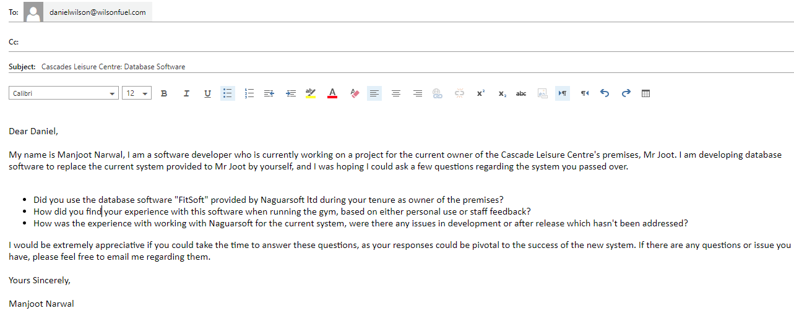
This email was then followed by a response from Daniel Wilson:
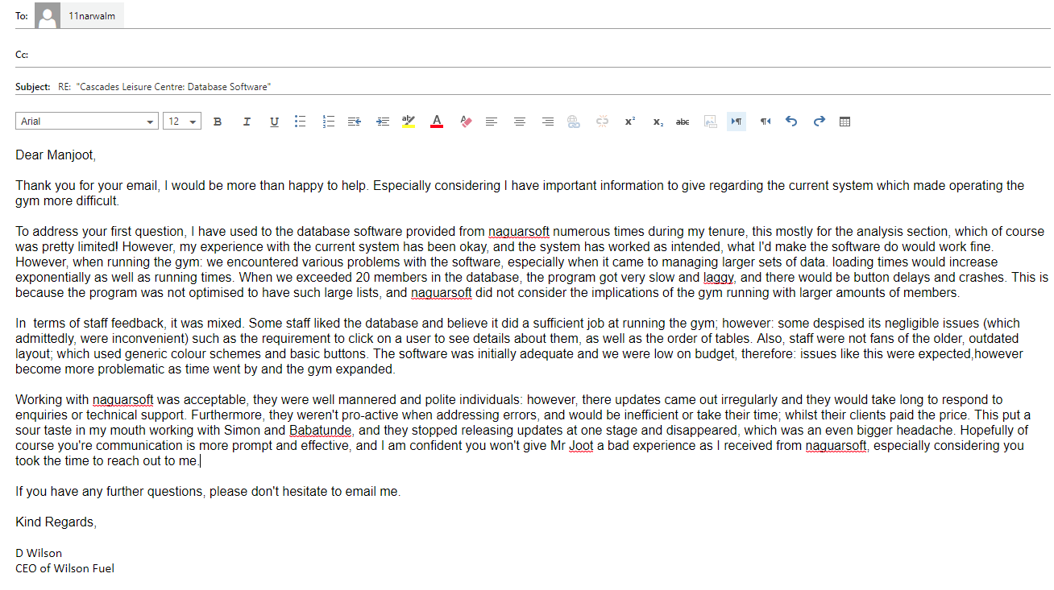

​​“Dear Manjoot,
Thank you for your email, I would be more than happy to help. Especially considering I have important information to give regarding the current system which made operating the gym more difficult.
To address your first question, I have used to the database software provided from naguarsoft numerous times during my tenure, this mostly for the analysis section, which of course was pretty limited! However, my experience with the current system has been okay, and the system has worked as intended, what I'd make the software do would work fine. However, when running the gym: we encountered various problems with the software, especially when it came to managing larger sets of data. loading times would increase exponentially as well as running times. When we exceeded 20 members in the database, the program got very slow and laggy, and there would be button delays and crashes. This is because the program was not optimised to have such large lists, and naguarsoft did not consider the implications of the gym running with larger amounts of members.
In terms of staff feedback, it was mixed. Some staff liked the database and believe it did a sufficient job at running the gym; however: some despised its negligible issues (which admittedly, were inconvenient) such as the requirement to click on a user to see details about them, as well as the order of tables. Also, staff were not fans of the older, outdated layout; which used generic colour schemes and basic buttons. The software was initially adequate and we were low on budget, therefore: issues like this were expected ,however become more problematic as time went by and the gym expanded.
Working with naguarsoft was acceptable, they were well mannered and polite individuals: however, there updates came out irregularly and they would take long to respond to enquiries or technical support. Furthermore, they weren't pro-active when addressing errors, and would be inefficient or take their time; whilst their clients paid the price. This put a sour taste in my mouth working with Simon and Babatunde, and they stopped releasing updates at one stage and disappeared, which was an even bigger headache. Hopefully of course you're communication is more prompt and effective, and I am confident you won't give Mr Joot a bad experience as I received from naguarsoft, especially considering you took the time to reach out to me.
If you have any further questions, please don't hesitate to email me.”

Conclusions Based on Response
Based on the email provided by Mr Daniel Wilson, I can conclude:

- The issues of speed have been evident for a while, as Mr Daniel Wilson expresses the fact that both his employees and himself have come across such issues during development. However, Mr Wilson says this happened when the gym exceeded 20 members, which suggests there was an issue in the way Naguarsoft stored the lists, or the lack of object oriented design potentially.
- The opinion on the program, even a while ago was mixed. Many disliked the basic look of the program with its dark blue colour scheme and grey buttons, but some saw it adequate and believed it did the job as it was intended to do.
- Mr Wilson also expresses his frustration with the lack of communication by Simon and Babatunde naguar, and with my endeavor to reach out to them not possible due to their lack of presence on the internet and in the software industry; I cannot get their side of the story. However, what Mr Wilson has stated has taught me the importance of keeping in communication with Mr Joot post-development, to prevent such issues like this from arising in the future.
- Mr Wilson said that he mainly used the analysis section, which was little in itself. This suggests that Mr Wilson may have not experienced the software fully for himself, and may be basing his conclusions from staff feedback.
- However, Mr Wilson states that aside from his issues with communication with Naguarsoft and lag issues, the software worked as intended and was adequate for its job. Therefore, on areas where FitSoft was effective, I could take inspiration for my prototype, this could be by button layout or searching.
- Therefore, I should take advice off this email to ensure that my prototype does not fall symptom to these various issues which have been mentioned by previous and current staff members, as well as the former and current owner of the premises.

Stakeholders
In this section I will be outlining the stakeholders within this project, these include:
- Mr Joot- Owner of Average Joot’s Gym: Mr Joot’s Responsibility is to overlook the entire operation of the gym, this includes how to premises operates as well as customers and finances. He has the most significant interest in this project due to him being the person to propose the project. Also, this project is in the interest of his business and his gym, and success can enhance the existing service he provides and improve performance of his business. With the new solution, Mr Joot will be able to improve productivity within his workforce due to the improved software and enable business operations to be completed more smoothly. With the new solution, he will have a more sophisticated interface to work with as well as modification features.
- Receptionists- Receptionists handle office-related work for Average Joots, Including member signups, enquiries and contact, and will most likely be using the database software the most excluding trainers and Mr Joot, therefore they will also have an significant interest in the database due to being frequent users. Therefore, a functioning and competent system will extremely benefit the receptionists, and an easy-to-navigate interface will be in their best interests. Therefore, I should consider this during this section of the project.
- Trainers- Trainers assess members level of physical fitness and help them set and reach their fitness goals, they often handle administrative duties e.g. scheduling personal training sessions for clients or creating programs. Therefore, the trainers would most likely use the database to create programs, make bookings for members and set goals for members. Therefore, I will need to include such features which enable trainers to complete these tasks, so I will need to consider their use within both the success criteria as well as development.
- The Administrator- The administrator will have special privileges in terms of access and use of the database, and will have access to the variable list and algorithms of the program, therefore: I must consider implementing features which can benefit the administrator in doing their jobs and completing tasks, and I need to develop the program with adaptability in mind, and in which it can be expanded.

Requirements Specification and Success criteria
Requirements Specification
The main objectives of the project are as followed, these being based on the needs/requirements outlined by Mr Joot in both the interview/discussion phase of this project as well as the other investigation methods completed:
- Create a professional, intuitive and user friendly system that appeals to the users and stakeholders. A system which is not too complicated but does not lack essential features.
- Create a login form, where staff can have various logins, and in which there are different levels of access.
- New Members can be added
- Existing Members can be modified
- Members can be deleted
- Members can be viewed and searched from via different search refinements
- New Trainers can be added
- Existing Trainers can be modified
- Trainers can be deleted
- Trainers can be viewed and searched from via different search refinements
- New Programs can be added
- Existing Programs can be modified
- Programs can be deleted
- Programs can be viewed and searched from via different search refinements
- New Staff Members can be added
- Existing Staff can be modified
- Staff Members can be deleted
- Staff can be viewed and searched from via different search refinements
- Bookings can be added
- Existing Bookings can be modified
- Bookings can be deleted
- Bookings can be viewed and searched from via different search refinements
- New Progress Goals can be added
- Existing Goals can be modified
- Goals can be deleted
- Goals can be viewed and searched from via different search refinements
- New Facilities can be added
- Existing Facilities can be modified
- Facilities can be deleted
- Facilities can be viewed and searched from via different search refinements
- New Salaries can be added
- Existing Salaries can be modified
- Salaries can be deleted
- Salaries can be viewed and searched from via different search refinements
- New Users can be added
- Users can be deleted
- Users can be viewed and searched from via different search refinements
- There is a section of basic analysis, which includes graphs for at least 3 different tables.
- The program must be able to maintain all of the data above and complete all functions accurately and correctly.
- The program must run with speed and efficiency, and be able to handle basic multitasking.
- The program must have compatibility in mind in terms of file storage.
- To ensure success, the project must be completed within the adequate time frame.

Methods to be used for the solution

- For the programming language, I will be using the programming language VB.net, via the IDE Visual Studio 2013. VB.net is a unique and easy to learn language based on Microsoft’s .NET framework.
- The .NET framework is a software framework that includes a large collection of libraries, which helps in development of more robust applications. It includes a virtual machine (CLR) that manages the execution of programs. Furthermore, the .NET framework supports many languages – and crucially, it allows language interoperability, whereby each language can use code written in other languages.
- VB.net was also considered a viable option as it supports object-oriented constructs such as abstraction, encapsulation, inheritance and polymorphism.
- I will obtain visual studio from our school computers, via their remote network; which contains the free version of Visual Studio 2013, including C# and VB.net.
- Furthermore, VB.net is an extremely easy-to-use IDE, it has many pre-built libraries from the .net framework which makes developing within VB.net easy and convenient compared to other languages such as Python and Java. Features such as the ability to debug, make breakpoints and create forms can be extremely beneficial in the development of the solution.
- Also, using VB.net can enable me to create installable packages, which may be useful for distribution of the software to other computer systems in the future , and making it easier for the software to be installed on computer systems.
- Overall, I believe that VB.net was the perfect IDE and language to use for this project due to both its extensive library, as well as the reduction in syntax knowledge which reduces both error frequency as well time.
- In terms of data structures, I will be using lists. This is because unlike conventional methods such as SQL, I will not have to encounter as many issues with syntax or logical errors, due to the simplicity of lists. This can make handling data easier and developing with data sets more convenient during development. Also, lists mean I do not have to integrate any third party addons or libraries, which can keep the program as barebones as possible, which can increase its speed.

